**Tugas Praktikum Komplesitas Waktu**

Disusun untuk memenuhi tugas praktikum mata kuliah Analisis Logaritma,



Muhammad Rifqy Aulia Akbar

140810160055

Departemen Ilmu Komputer, Fakultas Matematika dan Ilmu Pengetahuan Alam, Universitas Padjadjaran

2018

1. **Mencari Nilai Max**
   * Algoritma

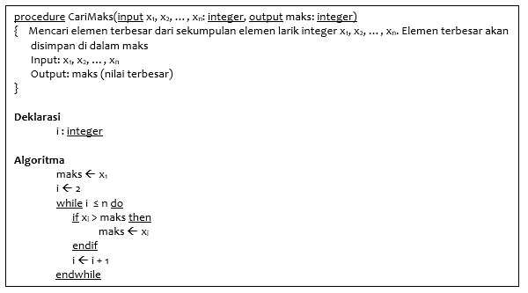

* + Code

#include <iostream>

using namespace std;

int main()

{

  int n;

  int x[10];

  cout << " Jumlah Data : ";

  cin >> n;

  for (int i = 0; i < n; i++)

  {

    cout << " Nilai Data ke - " << i+1 << " : ";

    cin >> x[i];

  }

  int maks = x[0];

  int i = 1;

  while (i <= n)

  {

    if (x[i] > maks)

      maks = x[i];

    i++;

  }

  cout << "Nilai Maksimum : " << maks << endl;

  return 0;

}

* + Analisis

maks 🡨 x1 1 kali

i 🡨 2 1 kali

maks 🡨 xi  n kali

i 🡨 i + 1 n kali

$$T\left(n\right)=1+1+n+n=2n+2$$

1. **Sequential Search**
   * Algoritma

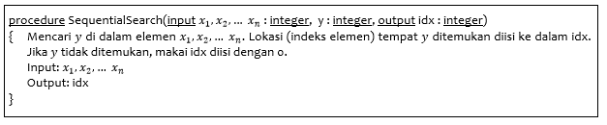

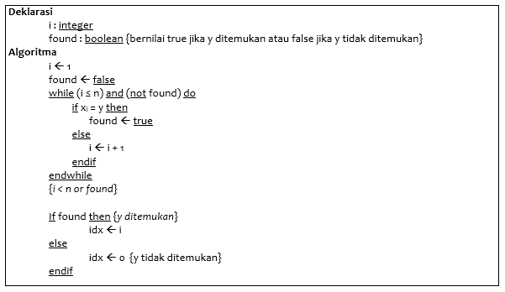

* + Code

#include <iostream>

using namespace std;

int main() {

  int n;

  int x[10];

  cout << "Masukkan Jumlah Data : ";

  cin >> n;

  for (int i = 0; i < n; i++){

    cout << "Masukkan Data ke - " << i+1 << " : ";

    cin >> x[i];

  }

  int y;

  cout << "Masukkan yang dicari : ";

  cin >> y;

  int i = 0;

  bool found = false;

  int idx;

  while ((i < n) && (!found)){

    if (x[i] == y)

      found = true;

    else

      i++;

  }

  if (found)

    idx = i+1;

  else

    idx = 0;

  cout << "Yang dicari berada di urutan : " << idx << endl;

  return 0;

}

* + Analisis

### Best Case :

i ←1 1 kali

found ←false 1 kali

found ←true 1 kali

idx ←I 1 kali

$T_{min}\left(n\right)=1+1+1+1=4$

### Average Case :

i ←1 1 kali

found ←false 1 kali

i ←i + 1 ½ n kali

found ←true 1 kali

idx ←I 1 kali

$T_{avg}\left(n\right)=1+1+ \frac{1}{2} n+1+1= \frac{1}{2} n+4$

### Worst Case :

i ←1 1 kali

found ←false 1 kali

i ←i + 1 n kali

found ←true 1 kali

idx ←I 1 kali

$$T_{max}\left(n\right)=1+1+n+1+1=n+4$$

1. **Binary Search**
   * Algoritma

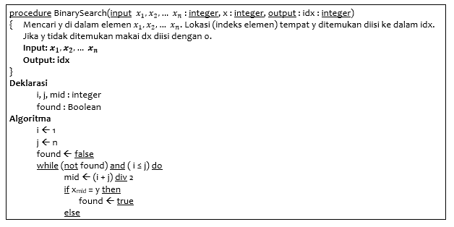

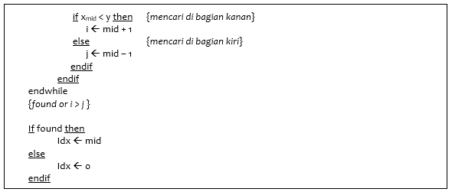

* + Code

#include <iostream>

using namespace std;

int main() {

  int n;

  int x[10];

  cout << "Masukkan Jumlah Data : ";

  cin >> n;

  for (int i = 0; i < n; i++){

    cout << "Masukkan Data ke - " << i+1 << " : ";

    cin >> x[i];

  }

  int y;

  cout << "Masukkan yang dicari : ";

  cin >> y;

  int i = 0;

  int j = n-1;

  bool found = false;

  int idx;

  int mid;

  while ((i <= j) && (!found)){

    mid = (i + j)/2;

    if (x[mid] == y)

      found = true;

    else{

      if (x[mid] < y)

        i = mid + 1;

      else

        j = mid - 1;

    }

  }

  if (found)

    idx = mid+1;

  else

    idx = 0;

  cout << "Yang dicari berada di urutan : " << idx << endl;

  return 0;

}

* + Analisis

### Best Case :

i ←1 1 kali

j ←n 1 kali

found ←false 1 kali

mid ←(i + j) div2 1 kali

found ←true 1 kali

Idx ←mid 1 kali

$$T_{min}\left(n\right)=1+1+1+1+1+1=6$$

### Average Case :

i ←1 1 kali

j ←n 1 kali

found ←false 1 kali

mid ←(i + j) div2 ½ n + 1 kali

i ←mid + 1 or j ←mid –1 ½ n kali

found ←true 1 kali

Idx ←mid 1 kali

$T_{avg}\left(n\right)=1+1+1+ \frac{1}{2}n+1+ \frac{1}{2}n+1+1=n+6$

`

### Worst Case :

i ←1 1 kali

j ←n 1 kali

found ←false 1 kali

mid ←(i + j) div2 n + 1 kali

i ←mid + 1 or j ←mid –1 n kali

found ←true 1 kali

Idx ←mid 1 kali

$$T_{max}\left(n\right)= 1+1+1+n+1+n+1+1=2n+6$$

1. **Insertion Sort**
   * Algoritma

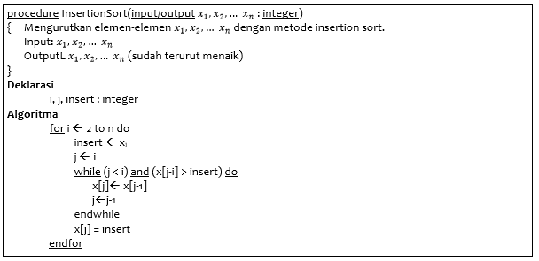

* + Code

#include <iostream>

using namespace std;

int main()

{

  int n;

  int x[10];

  cout << "Masukkan Jumlah Data : ";

  cin >> n;

  for (int i = 0; i < n; i++)

  {

    cout << "Masukkan Data ke - " << i+1 << " : ";

    cin >> x[i];

  }

  cout << "Data Sebelum di Sorting : ";

  for (int i = 0; i < n; i++)

    cout << x[i] << " ";

  cout << endl;

  int insert;

  int j;

  for (int i = 1; i < n; i++)

  {

    insert = x[i];

    j = i-1;

    while ((j >= 0) && (x[j] > insert))

    {

      x[j+1] = x[j];

      j--;

    }

    x[j+1] = insert;

  }

  cout << "Data setelah di Sorting : ";

  for (int i = 0; i < n; i++)

    cout << x[i] << " ";

  return 0;

}

* + Analisis

### Best Case :

For i ←2 to n do 1 kali

insert ←xi n kali

j ←i n kali

x[j] = insert n kali

$$T_{min}\left(n\right)=1+n+n+n=3n+1$$

### Average Case :

For i ←2 to n do 1 kali

insert ←xi n kali

j ←I n kali

x[j]←x[j-1] n * ½ n kali

j←j-1 n * ½ n kali

x[j] = insert n kali

$$T_{avg}\left(n\right)=1+n+n+\frac{1}{2} n^{2}+ \frac{1}{2} n^{2}+n=n^{2}+3n+1$$

### Worst Case :

For i ←2 to n do 1 kali

insert ←xi n kali

j ←i n kali

x[j]←x[j-1] n * n kali

j←j-1 n * n kali

x[j] = insert n kali

$$T_{max}\left(n\right)=1+n+n+ n^{2}+ n^{2}+n=2n^{2}+3n+1$$

1. **Selection Sort**
   * Algoritma

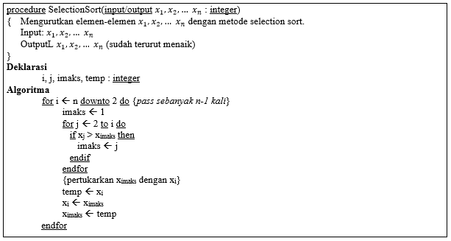

* + Code

#include <iostream>

using namespace std;

int main(){

  int n;

  int x[10];

  cout << "Masukkan Jumlah Data : ";

  cin >> n;

  for (int i = 0; i < n; i++){

    cout << "Masukkan Data ke - " << i+1 << " : ";

    cin >> x[i];

  }

  cout << "Data Sebelum di Sorting : ";

  for (int i = 0; i < n; i++)

    cout << x[i] << " ";

  cout << endl;

  int imaks;

  int temp;

  for (int i = n-1; i >= 1; i--){

    imaks = 0;

    for (int j = 1; j <= i; j++){

      if (x[j] > x[imaks])

        imaks = j;

    }

    temp = x[i];

    x[i] = x[imaks];

    x[imaks] = temp;

  }

  cout << "Data setelah di Sorting : ";

  for (int i = 0; i < n; i++)

    cout << x[i] << " ";

  return 0;

}

* + Analisis

### Best Case :

for i ←n downto 2 do 1 kali

imaks ←1 n kali

for j ←2 to i do n kali

imaks ←j n*1 kali

temp ←xi n kali

xi←ximaks n kali

ximaks←temp n kali

$$T_{min}\left(n\right)=1+n+n+n*1+n+n+n=6n+1$$

### Average Case :

for i ←n downto 2 do 1 kali

imaks ←1 nkali

for j ←2 to i do n kali

imaks ←j n * ½ n kali

temp ←xi n kali

xi←ximaks n kali

ximaks←temp n kali

$$T_{avg}\left(n\right)=1+n+n+ \frac{1}{2}n^{2}+ n+n+n= \frac{1}{2}n^{2}+5n+1$$

### Worst Case :

for i ←n downto 2 do 1 kali

imaks ←1 n kali

for j ←2 to i do n kali

imaks ←j n * n kali

temp ←xi n kali

xi←ximaks n kali

ximaks←temp n kali

$$T_{max}\left(n\right)= 1+n+n+n^{2}+ n+n+n= n^{2}+5n+1$$